ROYAL TUNBRIDGE WELLS TOWN CENTRE PLAN – CALL FOR SITES
SITE SUBMISSION FORM
June 2023

﻿Tunbridge Wells Borough Council is carrying out a ‘Call for Sites’ as part of the production of a ‘Royal Tunbridge Wells Town Centre Sites Assessment’ (RTWTCSA) evidence base for the Royal Tunbridge Wells Town Centre Plan. This will help to identify available and suitable sites to be considered to deliver the strategy and vision for Royal Tunbridge Wells Town Centre over the next 15 years until 2040. The Submission Local Plan (October 2021) includes Policy STR/RTW 2 – The Strategy for Royal Tunbridge Wells Town Centre which sets out the strategy for the town centre, which will be taken forward in the Royal Tunbridge Wells Town Centre Plan.
All sites submitted must be located within the Royal Tunbridge Wells Town Centre Boundary. However, the submission of sites which straddle the boundary (i.e. partly located within and partly outside the Boundary) will also be considered:
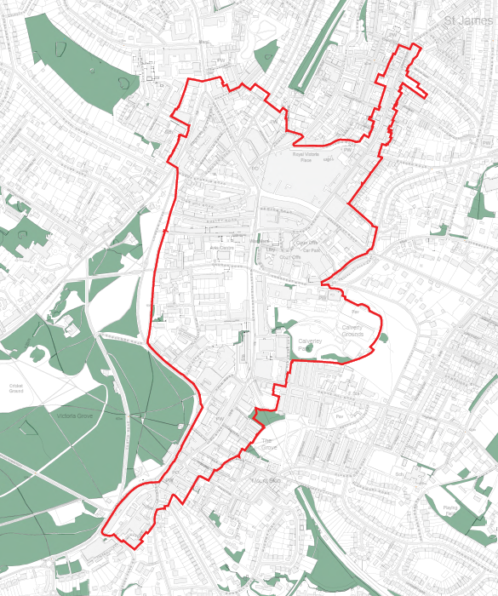
Map showing Royal Tunbridge Wells Town Centre Boundary
Any sites submitted which clearly fall outside of this Boundary will not be considered, due to the geographical extent to which the Royal Tunbridge Wells Town Centre Plan relates.
Sites submitted as part of this ‘Call for Sites’ will be assessed for their suitability for development together with the likelihood of them being available and achievable for development. It must be noted that even if land is identified by the ‘Royal Tunbridge Wells Town Centre Sites Assessment’ as having potential for development - this does not in any way indicate or confirm that it will be allocated for development in the Royal Tunbridge Wells Town Centre Plan, or that it will get planning permission in the future. The main purpose of the Call for Sites exercise is to provide the Council with an initial list of sites to consider in identifying potential land use supply for the Town Centre Plan.
The following form should be completed as fully as possible to include the relevant details to enable the Council to consider the site and its suitability for allocation within the Royal Tunbridge Wells Town Centre Plan.
Before you start filling in the form:
Please read through the form first and make sure you have all the information readily to hand. You will be asked to attach a map (a site location plan clearly identifying the extent of the site boundary of the land you wish to submit for assessment), and so it is recommended that you have the map already saved on your computer. Please see section 7 of the form for more detail about how to produce a map.
If you are submitting more than one site, a separate form and map should be submitted for each site.
How we will use your personal information included in the site submission form
Submissions to the Call for Sites cannot be treated in confidence and copies of all representations may be made publicly available. The Council will provide details of submissions on its website but will not publish personal information such as signatures, telephone numbers, emails, or private addresses in relation to those submissions to the Call for Sites
The information you provide will be used by the Council to help prepare the Royal Tunbridge Wells Town Centre Sites Assessment for the Royal Tunbridge Wells Town Centre Plan. The Council will enter responses onto a computer database for the purpose of recording and collating information. This will be used to make an initial appraisal of sites that might be taken forward for allocation in the Royal Tunbridge Wells Town Centre Plan.
Information about sites submitted through the Call for Sites may be published on the Council’s website before the completion of the Royal Tunbridge Wells Town Centre Sites Assessment document. This will include an interactive map to show the location of submitted sites in relation to other sites and the town centre boundary.
Please click on the link below to find out more information about the Council’s Planning Policy Privacy Notice: Planning Policy Privacy Notice
By completing the Call for Sites form you confirm that you agree to this and accept responsibility for your comments.

SITE SUBMISSION FORM

- PERSONAL DETAILS

Please complete all fields that are relevant. The fields marked * are mandatory

Name * | Click or tap here to enter text.
The organisation you represent, if applicable | Click or tap here to enter text.
Postal address (including post code) * | Click or tap here to enter text.
Telephone Number * | Click or tap here to enter text.
Email address | Click or tap here to enter text.
Are you submitting a site/site in your capacity as any of the following * | ☐ landowner  ☐ agent  ☐ developer  ☐ town or parish council  ☐ civic society or town forum  ☐ amenity or community group  ☐ other
If you ticked ‘other’, please clarify: | Click or tap here to enter text.
Date of submission | Click or tap here to enter text.
- SITE OWNER DETAILS
If you are representing the owner of a site, please give their full details below
How many people own the site? | Click or tap here to enter text.
The owner’s name (or organisation (if applicable)  If more than one, please include details of all known landowners | Click or tap here to enter text.
The owner(s)’s address (including post code) | Click or tap here to enter text.
The owner’s telephone number | Click or tap here to enter text.
The owner’s email address | Click or tap here to enter text.
Please also explain the nature of the owner(s) interest (e.g. leaseholder, freeholder, etc) | Click or tap here to enter text.
Does the owner of the site know that you are submitting this site for consideration? | ☐ Yes ☐ No
- SITE DETAILS
Please provide details of the site including if you are submitting the entire plot/building or part.

Site address (including the post code if the site has one) | Click or tap here to enter text.
OS grid reference (centre of site) if known | Click or tap here to enter text.
Site area (sqm or hectares) | Click or tap here to enter text.
What is the site's current use (or most recent use)? Please include number and type of buildings currently on the site, if known and if the whole site/building is being submitted for consideration. | Click or tap here to enter text.
- CURRENT AND POTENTIAL FUTURE USE
Please specify the current and potential future use of the site
Preferred future use(s) of the site | Please tick all that apply:  ☐ residential  ☐ elderly housing/care home  ☐ commercial (general)  ☐ office  ☐ retail  ☐ leisure  ☐ community facilities  ☐ educational facilities  ☐ energy generation  ☐ other
If you ticked ‘other’, or commercial (general) please clarify: | Click or tap here to enter text.
- POSSIBLE CONSTRAINTS
This section deals with the suitability of a site for future development. Please indicate any known constraints that may affect the future development of the site
Environmental Constraints | Please tick all that apply:  ☐ flood risk  ☐ drainage  ☐ contamination  ☐ other
If you ticked ‘other’, please clarify: | Click or tap here to enter text.
If you ticked any of the boxes, please give further details | Click or tap here to enter text.
Physical and Infrastructure Constraints | Please tick all that apply:  ☐ vehicular access  ☐ pedestrian access  ☐ topography  ☐ trees/hedges  ☐ utilities infrastructure  ☐ other
If you ticked ‘other’, please clarify: | Click or tap here to enter text.
If you ticked any of the boxes, please give further details | Click or tap here to enter text.
- AVAILABILITY AND DELIVERY
This section deals with the availability of the site and the estimated rate of delivery
When would you anticipate the site being available for development to start? | ☐ within the next five years  ☐ within the next six to 10 years  ☐ within the next 11-15 years
When would you anticipate development being completed? | ☐ within the next five years  ☐ within the next six to 10 years  ☐ within the next 11-15 years
Please include details of phasing as appropriate: | Click or tap here to enter text.
Please state any other issues that the Council should be aware of (that are not already covered by the questions above) that could delay the site coming forward for development. For example, are there any covenants, leases or ransoms which would affect when the land may become available or how the site could be developed? | Click or tap here to enter text.
- SITE VISITS
Sites that are submitted may be visited by Borough Council officers as part of the assessment of sites.
In identifying such a site, you are giving permission for an officer of the Council to access the site in order to ascertain site suitability.
Please note it will not be possible to accompany Council officers during a site visit
In identifying such a site, you are giving permission for an officer of the Council to access the submitted site in order to ascertain site suitability. In this context, would there be any access issues to the site?  If yes, please provide contact details of the person who should be contacted to arrange a site visit to the submitted site | Click or tap here to enter text.
﻿Would it be necessary for the Council Officer to go onto any privately owned adjoining land not in the same ownership as the submitted site?  If yes, please provide contact details of any person(s) who should be contacted to make arrangements to go onto any adjoining land for the purpose of carrying out a site visit to the submitted site. | Click or tap here to enter text.
- ATTACH A MAP  Please attach an ordnance survey map (s) (preferably at 1:1250 scale, or 1:12500 scale for larger sites) outlining the precise boundaries of the site in its entirety, indicating the area of the site which may be suitable for development if this is less than the whole of the site. This should also include a direction of north point.  You may wish to use our TWBC mapping tool to produce a site plan.  Alternatively, you can use your own map and submit it with the form.  Please ensure that the site is located within the Royal Tunbridge Wells Town Centre Boundary. Or where it straddles the Boundary, that it is partially located within it. Any sites submitted which clearly fall outside of this Boundary will not be considered.  Please indicate on the map any adjoining land that is in the same ownership as the site being submitted.  The Council will be unable to register a site without all of this mapped information. | Click or tap here to enter text.
- ADDITIONAL INFORMATION  Please provide any other relevant information or considerations about the site that you want to make us aware of: | Click or tap here to enter text.

WHAT HAPPENS NEXT?
﻿The Call for Sites will run until midnight on Friday 18 August 2023.
How to Submit the Form
This site submission form (along with a site location plan showing the extent of the site boundary) should be completed as fully as possible to include the relevant details to enable the Council to consider the site and its suitability for allocation within the Royal Tunbridge Wells Town Centre Plan.
Please return this form by midnight on Friday 18 August 2023, together with a map that clearly identifies the boundary of the site. The form can be submitted:

On-line: The preferred method for completing this form is by using the on-line facility at https://tunbridgewells-consult.objective.co.uk/kse/

Or by email: Alternatively, this form can be downloaded as a word document or printed and scanned and emailed to: RTWTownCentrePlan@tunbridgewells.gov.uk;

Or by post to:

Planning Policy,
Planning Services,
Tunbridge Wells Borough Council,
Town Hall,
Royal Tunbridge Wells,
Kent TN1 1RS

Again, it should be noted that the Royal Tunbridge Wells Town Centre Sites assessment is a technical assessment document that will help to identify a potential land supply. It will not represent a commitment for development of a site or indicate that planning permission would be granted should an application be submitted.

