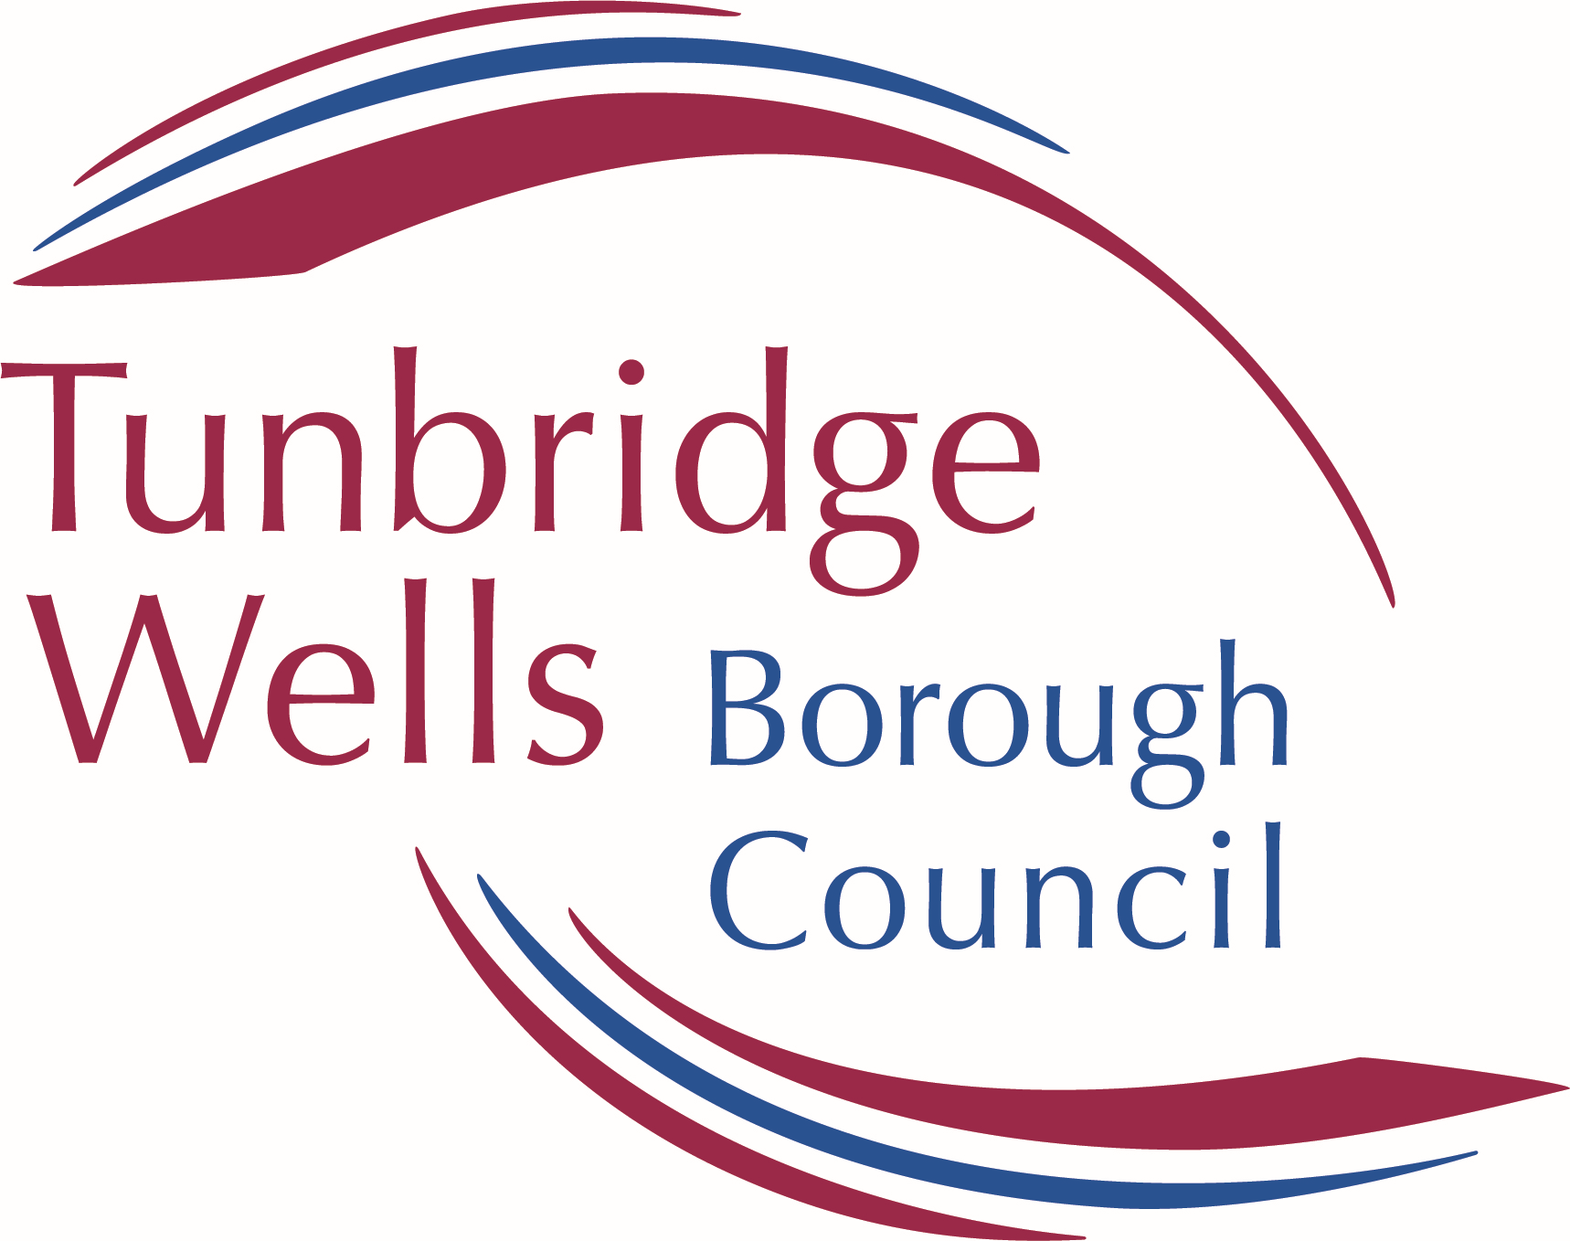 | Draft Royal Tunbridge Wells Town Centre Plan – Vision 2040  Representation Form  Please use a separate sheet for each representation | Ref:  (For official use only)

Name of the Local Plan to which this representation relates: | Draft Royal Tunbridge Wells Town Centre Plan – Vision 2040 (Regulation 18 (Part 1) consultation)

Public Consultation on the Draft Royal Tunbridge Wells Town Centre Plan - Vision 2040

Tunbridge Wells Borough Council is currently preparing a Royal Tunbridge Wells Town Centre Plan. This consultation is the first stage in the process of preparing the Plan, called the Draft Royal Tunbridge Wells Town Centre Plan – Vision 2040, and the Council really want your views at this early stage in the process.

There is a public consultation during which time your views and representations may be made. This runs from Friday 23 February and completed forms must be received at our offices by midnight on Monday 15 April 2024.

Further details about the consultation including all consultation documents, a virtual exhibition and interactive map (where you can drop in suggestions) can be found here https://consult.tunbridgewells.gov.uk/kse/ on the Council’s consultation portal and here https://tunbridgewells.gov.uk/planning/planning-policy/rtw-town-centre-plan on the Council’s website.

We encourage you to respond online using the consultation portal. Please note you do not have to sign in to respond via the portal: https://consult.tunbridgewells.gov.uk/kse/

Alternatively, you may email or scan forms to: RTWTownCentre Plan@TunbridgeWells.gov.uk or send them by post to: Tunbridge Wells Borough Council, PLANNING POLICY, Town Hall, Royal Tunbridge Wells, TN1 1RS.

Please note that representations must be attributable to named individuals or organisations. They will be available for public inspection and cannot be treated as confidential.
Please also note that all comments received will be available for the public to view and cannot be treated as confidential. Data will be processed and held in accordance with the Data Protection Act 2018 and the General Data Protection Regulations 2018.
PART A – CONTACT DETAILS

 | 1. Personal Details | 2. Agent Details (if applicable)
Title
First Name
Last Name
Job title
(where relevant)
Organisation
(where relevant)
Address Line 1
Address Line 2
Address Line 3
Address Line 4
Postcode
Telephone number
Email address (where relevant)

PART B – YOUR REPRESENTATION
(Please use a separate sheet for each representation)
The following questions replicate those that are included in the Draft Royal Tunbridge Wells Town Centre Plan - Vision 2040 (Regulation 18 (Part 1) consultation).

Name or Organisation
Age range (leave blank if responding on behalf of an organisation) | 16 and under☐ 17-25☐ 26-35☐ 36-45☐  46-55☐ 56-65☐ 66+☐

Question 1. Do you agree with the Draft Vision for the Town Centre? If no, why not?
Question 2. Does it reflect what you think is important about the town and how it should develop in the future? If no, then please make suggestions of what else you think is important?

Question 3. Do you think it is realistic or ambitious enough? If no, please specify?
Question 4. Is there anything else that you think should be added to the vision? Please specify?

Question 5. What do you think about the seven ‘principles? Do you think anything else should be included?
Question 6. Do you think that the SWOT analysis below identifies all of the Strengths, Weaknesses, Opportunities and Threats applicable to Royal Tunbridge Wells Town Centre? Please let us know if you think anything else should be added to the SWOT?
Question 7. Do you have any comments on the Masterplan Framework – please specify?
Question 8. Please specify any other improvements/opportunities you think are important for the North Quarter?
Question 9. Please specify any other improvements/opportunities you think are important for the East Quarter?
Question 10. Please specify any other improvements/opportunities you think are important for the West Quarter?

Question 11. Please specify any other improvements/opportunities you think are important for the West Quarter?
Question 12. Do you have any comments on the sites listed? Please specify which site and your comments/suggestions?
Question 13. Are there any other sites that you think should be considered through the Royal Tunbridge Wells Town Centre Plan? See link to ‘Call for Sites’ information and site submission form.
Question 14. Do you support the vision, principles and ambitions set out in this document? Do you think anything else needs considering? Please specify?
Question 15. Do you have any other comments on this document or the Royal Tunbridge Wells Town Centre Plan generally? Please specify?

Signature |  | Date

